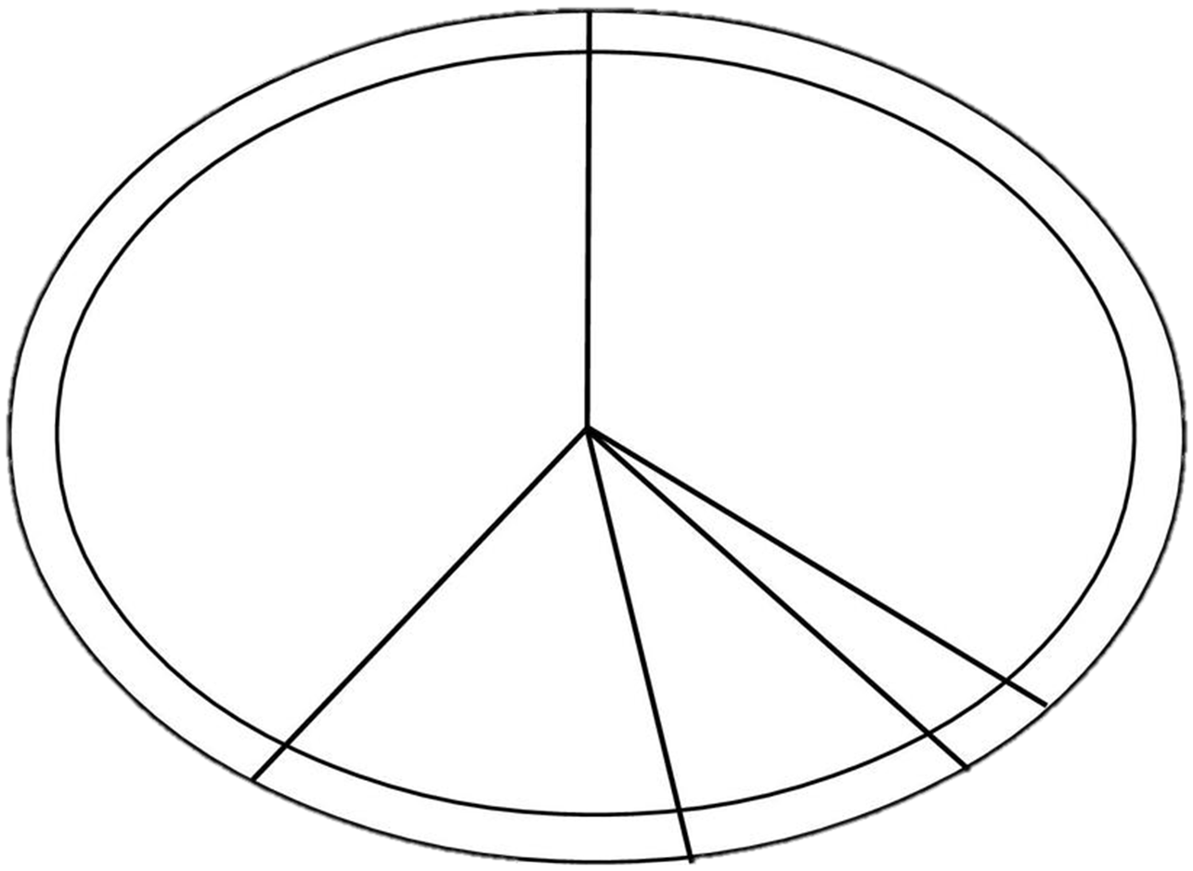Plan a meal that follows the Eatwell Guide. Draw and label the ingredients. Remember to add a drink!

My meal is;

We will drink

